Consider the following circuit:

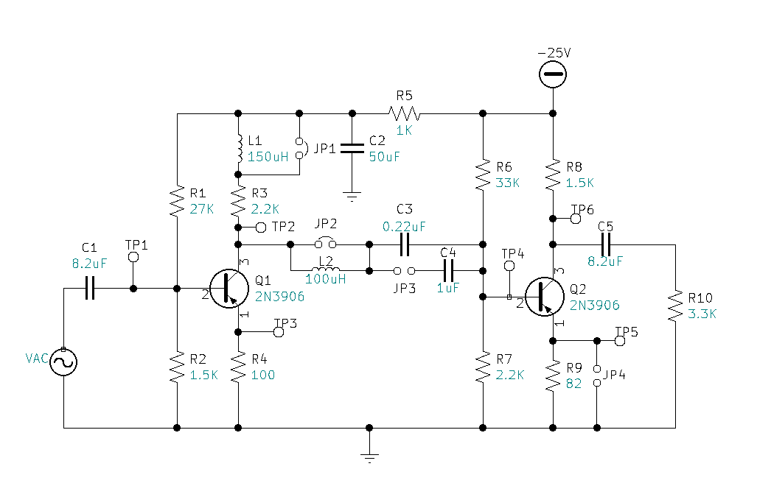NOTE: On the 2-stage schematic, VCC=25V. There is a jumper on JP1 and JP2. No Jumper on JP3 and JP4.

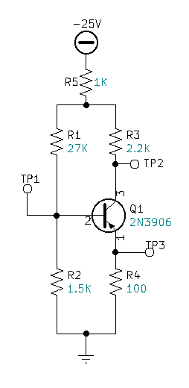

DC Redraw for Stage 1:

DC Calculations for Stage 1:

Kirchhoff Loop Equation 1:

$VCC-VR5-VR1-VBE-VRE=0$

$IR5\left(1K\right)+IR1\left(27K\right)+IE\left(82\right)=24.3V$

Kirchhoff Loop Equation 2:

$VCC-VR5-VR1-VR2=0$

$IR5\left(1K\right)+IR1\left(27K\right)+IR2\left(1.5K\right)=25V$

Kirchhoff’s Current Law:

$IR5=IR1+ICQ1$

$IR2=IR1-IBQ1$

Substitute Currents:

$(IR1+ICQ1)\left(1K\right)+IR1\left(27K\right)+IE\left(100\right)=24.3V$

$(IR1+ICQ1)\left(1K\right)+IR1\left(27K\right)+(IR1-IBQ1)\left(1.5K\right)=25V$

Manipulate into terms of IR1 and IB:

$(IR1+(IBxB))\left(1K\right)+IR1\left(27K\right)+(IBx(B+1))\left(100\right)=24.3V$

$(IR1+(IBxB))\left(1K\right)+IR1\left(27K\right)+(IR1-IB)\left(1.5K\right)=25V$

Beta = 100:

$(IR1+(IBx100))\left(1K\right)+IR1\left(27K\right)+(IBx(100+1))\left(100\right)=24.3V$

$(IR1+(IBx100))\left(1K\right)+IR1\left(27K\right)+(IR1-IB)\left(1.5K\right)=25V$

Simplify:

$(1KIR1+(100KIB)+IR1\left(27K\right)+(10.1KKIB)=24.3V$

$(1KIR1+(100KIB)+IR1\left(27K\right)+(1.5KIR1-1.5KIB)=25V$

Simplify:

$28KIR1+110.1KIB=24.3V$

$29.5KIR1+98.5KIB=25V$

Simultaneous Equation Solution:

$IR1=732.626uA$

$IB=34.391uA$

DC/Bias Voltages:

$VR1=IR1×R1$

$VR1=732.626uA×27K$

$VR1=19.78V$

$VR2=IR2×R2$

$VR2=(IR1-IB)×R2$

$VR2=(732.626uA-34.391uA)×1.5K$

$VR2=1.047V$

$VR4=(IBX(B+1))×R4$

$VR4=(34.391uAX(101))×100$

$VR4=347.349mV$

$VR3=(IBX(B))×R3$

$VR3=(34.391uAX(100))×2.2K$

$VR3=7.566V$

$VR5=(IBX\left(B\right)+IR1)×R5$

$VR5=(34.391uAX\left(100\right)+732.626uA)×1K$

$VR5=4.172V$

Kirchhoff, check math:

* 🗹

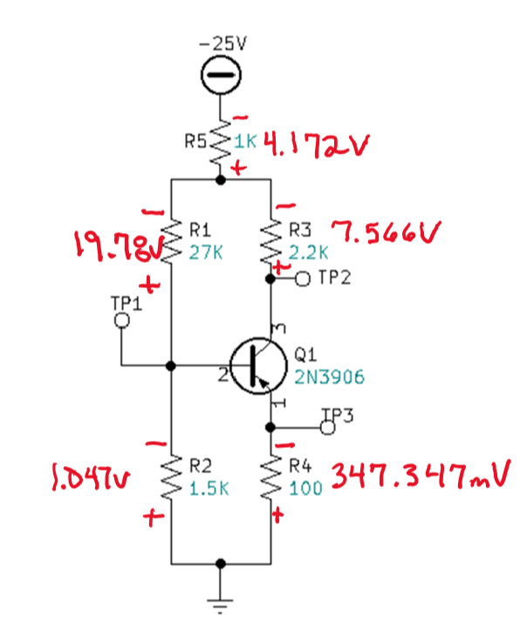Find VCE:

$+VCC-VR5-VR3-VCE-VR4=0$

$+25V-4.172V-7.566-VCE-347.347mV=0$

$+13.142V-VCE=0$

$VCE=13.142V$

Test Point Voltages:

$TP1=VR2$

$TP1=-1.047V$

$TP2=VCE+VR4$

$TP2=-13.142V-347.347mV$

$TP2=-13.489V$

$TP3=VR4$

$TP3=-347.347mV$

DC Load Line for Q1:

* *=*
  + - *=*
    - *=*
    - *=*
    - *=*

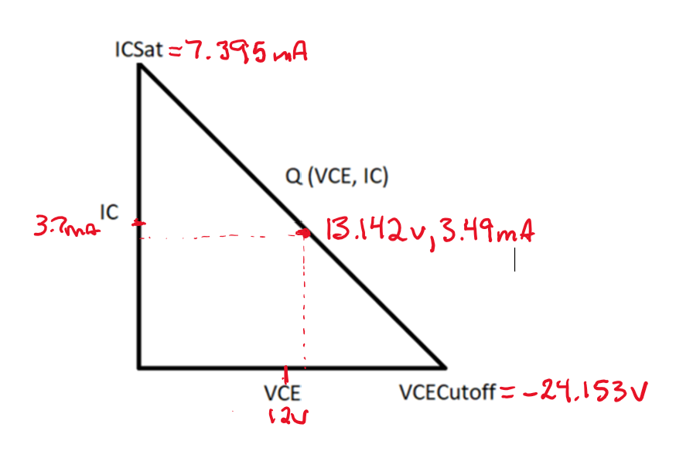

DC Redraw for Stage 2:

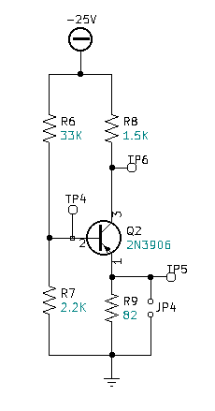

DC Calculations for Stage 2:

Kirchhoff Loop Equation 1:

$VCC-VR6-VR7=0$

Kirchhoff Loop Equation 2:

$VCC-VR6-VBE-VR9=0$

Substitute Currents & known values:

$25V-33K(IR6)-2.2K(IR7)=0$

$25V-33K(IR6)-0.7V-82(IR9)=0$

Substitute Currents in terms of IR6 & IB:

$25V-33K(IR6)-2.2K(IR6-IB)=0$

$25V-33K(IR6)-0.7V-82(IB(B+1))=0$

Simplify:

$25V-33K\left(IR6\right)-2.2KIR6+2.2K(IB)=0$

$25V-33K(IR6)-0.7V-82(IB(101))=0$

Simplify:

$35.2K\left(IR6\right)-2.2K(IB)=25V$

$33K\left(IR6\right)+8.282K(IB)=24.3$

Simultaneous Equation Solution:

$IR6=715.438uA$

$IB=83.378uA$

DC/Bias Voltages:

$VR6=IR6×R6$

$VR6=715.438×33K$

$VR6=23.61V$

$VR7=IR7×R7$

$VR7=(715.438-83.378uA)×2.2K$

$VR7=1.391V$

$VR8=IR8×R8$

$VR8=IB(beta)×1.5K$

$VR8=83.378uA(100)×1.5K$

$VR8=12.51V$

$VR9=IR9×R9$

$VR9=IB(beta+1)×82$

$VR9=83.378uA(101)×82$

$VR9=690.537mV$

$VCE=VCC-VR8-VR9$

$VCE=25-12.51-690.537mV$

$VCE=11.8V$

$TP4=1.391V$

$TP5=690.537mV$

$TP6=12.5V$

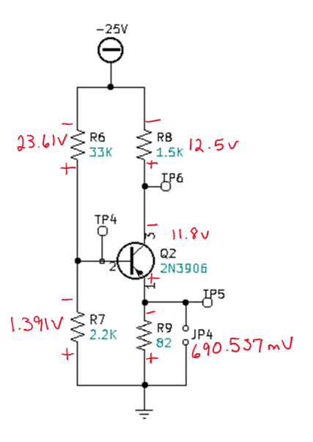

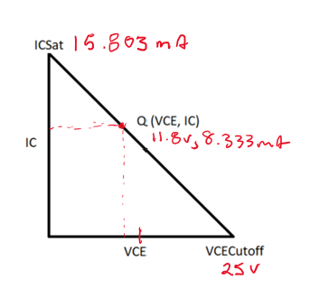DC Load Line for Q2:

* *=*
  + - *=*

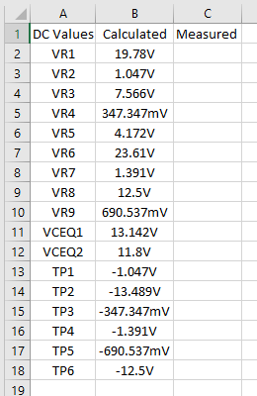DC Calculations Tabulated:

AC Calculations:

$∆VQ2=\frac{Vout}{Vin}$

$∆VQ2=\frac{IC(R8//R10)}{IB(R9+r^{'}e)(B+1)}$

$∆VQ2=Beta\frac{(1.5K//3.3K)}{(82+3.087)(101)}$

$∆VQ2=100\frac{(1.03125K)}{(8.594K)}$

$∆VQ2=-12$

$∆VQ1=\frac{Vout}{Vin}$

$∆VQ1=\frac{IC((R3//R6//R7//(R9+r^{'}e)(B+1)}{IB(R4+r^{'}e)(B+1)}$

$∆VQ1=Beta\frac{((2.2K//33K//2.2K//(82+3.087)(101))}{(100+7.485)(101)}$

$∆VQ1=100\frac{((2.2K//33K//2.2K//(8.594K))}{(107.485)(101)}$

$∆VQ1=100\frac{947.19}{10.856K}$

$∆VQ1=-8.725$

AC Calculations Continued:

* 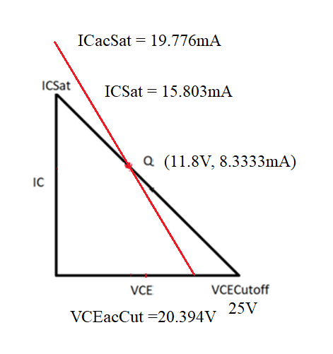



Frequency Response Low:

* Rules:
  + Treat all caps like opens.
  + Thevenize each and find Fc for each cap

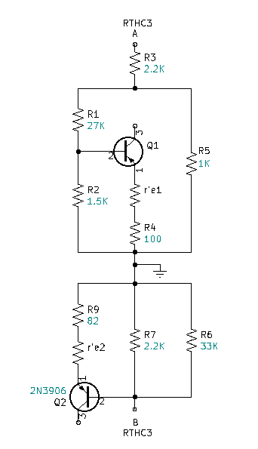



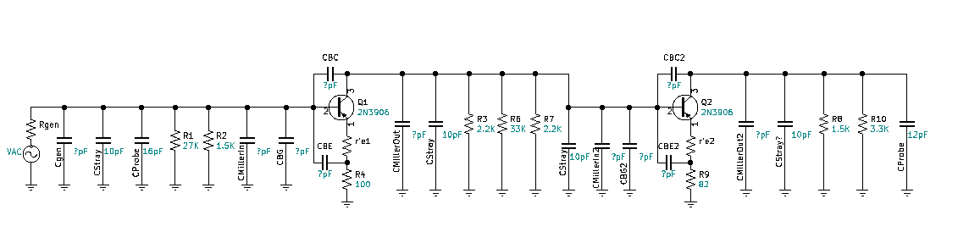Frequency Response High:

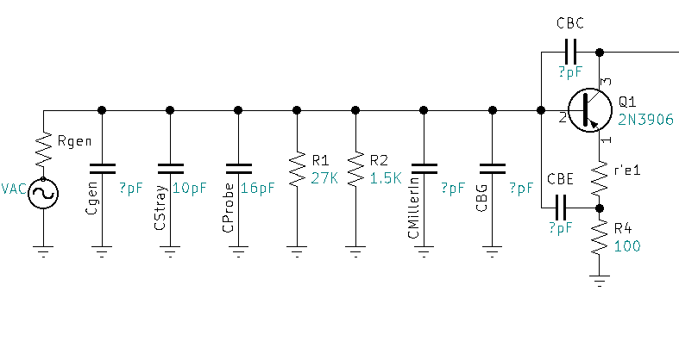Frequency Response High (Front End):

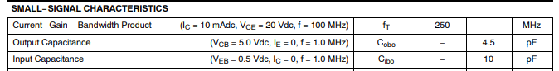

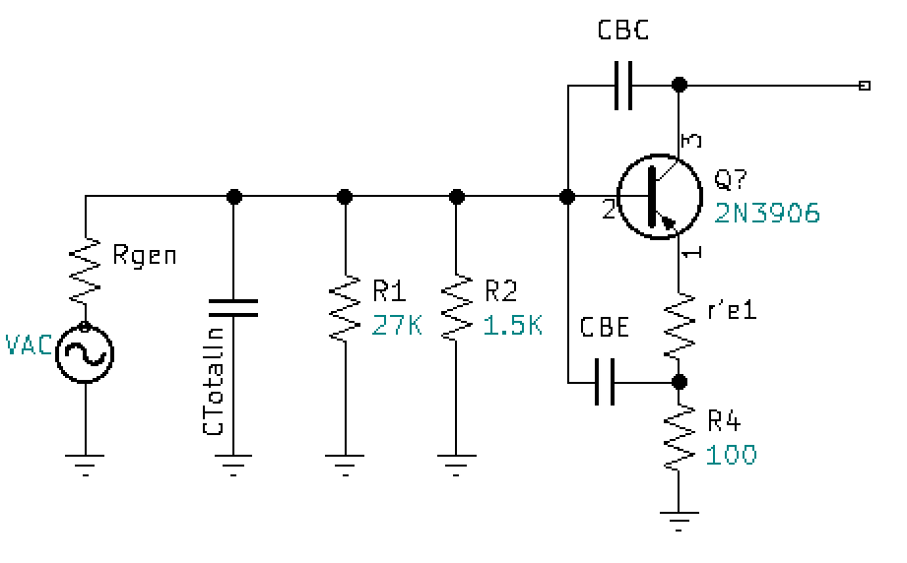

* + - or $\frac{(RE)}{(RE+r^{'}e)}$
 $∆V_{CC}=$ $\frac{(100)}{(100+7.485)}=0.930$

 $CBE$ - = $\frac{1}{(2π)(r^{'}e)(f_{T})}=\frac{1}{(2π)(7.485)(250M)}=85.053pF$

$CBG=85.053pF\left(1-0.93\right)$

$CBG=5.954pF$

$CtotalIN=Cgen+Cstray+Cprobe+CmillerIN+CBG$

$CtotalIN=40pF+10pF+16pF+43.763pF+5.954pF$

$CtotalIN=115.717pF$

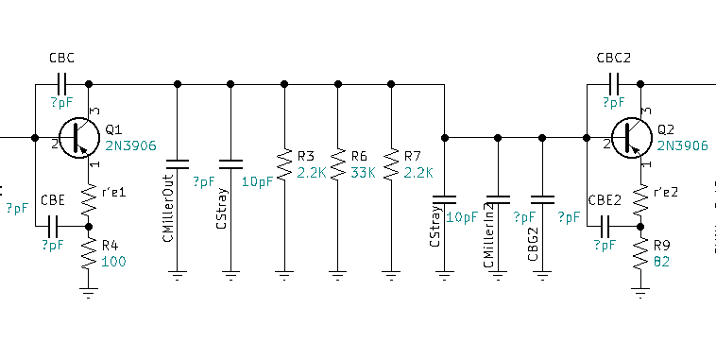Frequency Response High (Middle):

* + - or $\frac{(RE)}{(RE+r^{'}e)}$
 $∆V_{CC}=$ $\frac{(82)}{(82+3.087)}=0.964$

 $CBE2$ - = $\frac{1}{(2π)(r^{'}e)(f_{T})}=\frac{1}{(2π)(3.087)(250M)}=206.226pF$

$CBG2=206.226pF\left(1-0.964\right)$

$CBG2=7.424pF$

$CtotalMid=5.016pF+10pF+10pF+58pF+7.424pF$

$CtotalMid=90.44pF$

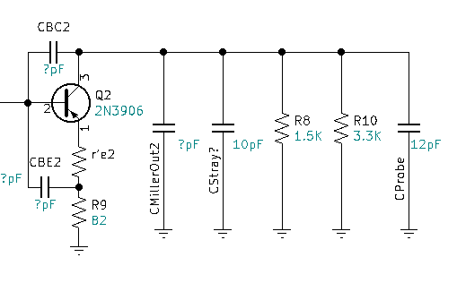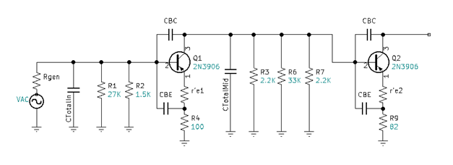Frequency Response High (Back End):

* )
  + - )

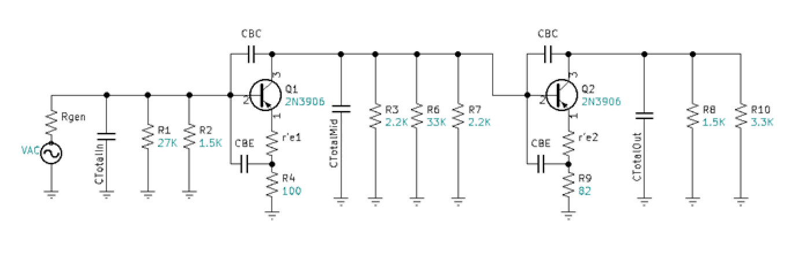

Simplify parallel resistances:

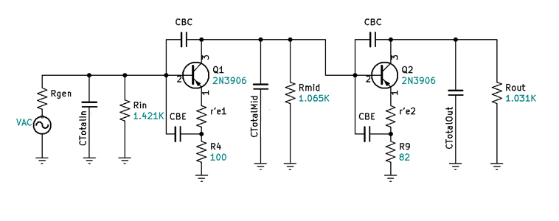



Thevenize for CTin, CTmid, & CTout:



$RthCtin=Rgen//Rin//[\left(r^{'}e1+R4\right)\left(B+1\right)]$

$RthCtin=50//1.421K//[\left(7.485+100\right)\left(101\right)]$ $=48.0865Ω$

$RthCtmid=Rmid//[\left(r^{'}e2+R9\right)\left(B+1\right)]$

$RthCtmid=1.065K//[\left(3.087+82\right)\left(101\right)]$ $=947.571Ω$

$RthCtout=Rout=1.031KΩ$

Find FCH for each stage:

$FCH=\frac{1}{2πR_{Thev }CT}$

${FCH}_{CTin}=\frac{1}{2π×48.0865×115.717pF}=28.6022Mhz$

${FCH}_{CTmid}=\frac{1}{2π×947.571×90.44pF}=1.857Mhz$

${FCH}_{CTout}=\frac{1}{2π×1.031K×30.767pf}=5.0174Mhz$

Find FCHtotal:

${FCH}_{Total}=\frac{.35}{\sqrt{{(\frac{.35}{{FCH}_{IN}})}^{2}+{(\frac{.35}{{FCH}_{OUT}})}^{2}}}$

${FCH}_{Total}=\frac{.35}{\sqrt{{(\frac{.35}{28.602Mhz})}^{2}+{(\frac{.35}{1.857Mhz})}^{2}{+(\frac{.35}{5.0174Mhz})}^{2}}}$

${FCH}_{Total}=1.738Mhz$

